**(DISM E-PROJECT ADDRESS BOOK)**

GROUP MEMBERS NAMES

* MUHAMMAD HASSAM FARHAN ( 1385298 )
* MUHHAMMAD BILAL ( 1381565 )
* ALISHA FATIMA ( 1385301 )
* SYEDA NAIMA SHAH ( 1425929 )

What is Address Book?

A address book system, also known as shopping software. It automates the many operations involved in delivery businesses, such as real-time tracking.

REQUIREMENTS OF OUR PROJECT

# System Modules:

**ADMIN**

* Add/Delete categories and products into the website.
* Update the information for the existing products.
* Maintenance of the web site
* Add / Delete records in database.
* Backup the database.
* Generate/View the report upon top 10 best selling products.
* Generate/View the report upon top 10 clients/users (doing maximum shopping).

## User

* Register
* Login

**Problem Statement**

Jenny is a doing business of cosmetics and imitation jewelry. She operates from home. Initially she started the entire activity by contacting the nearby friends and relatives, inform them about the various products available with her and their prices. Maria used to maintain the catalogue of products to display and diary for contacting the clients wherein she used to record their contact details and also to record their orders.

With the growing demands of the business and as the number of clients is increasing day by day, she wishes to have a web site with the complete product list for the user, also user should be able to place the order using the website.

Web site should also record the complete information regarding the client.

**Customer Specifications:**

The user should be able to do the following:

1. Browse through the categories and products available and should be able to add products to the shopping basket.
2. User should be able to specify the quantity of the products required.
3. Complete / Finalize the order.
4. While ordering the product the user should input the following information:
   * Name
   * Address
   * E-mail
   * Work Phone No.
   * Cell No.
   * Date Of Birth
   * Category
   * Remarks(other additional informational)
5. The user should be able to search a product by name.

Administrator should be able to do the following:

1. Add/Delete categories and products into the website.

1. Update the information for the existing products.
2. Maintenance of the web site
3. Add / Delete records in database.
4. Backup the database.
5. Generate/View the report upon top 10 best selling products.
6. Generate/View the report upon top 10 clients/users (doing maximum shopping).

**OUR PROJECT IMAGES**

**HOME PAGE**

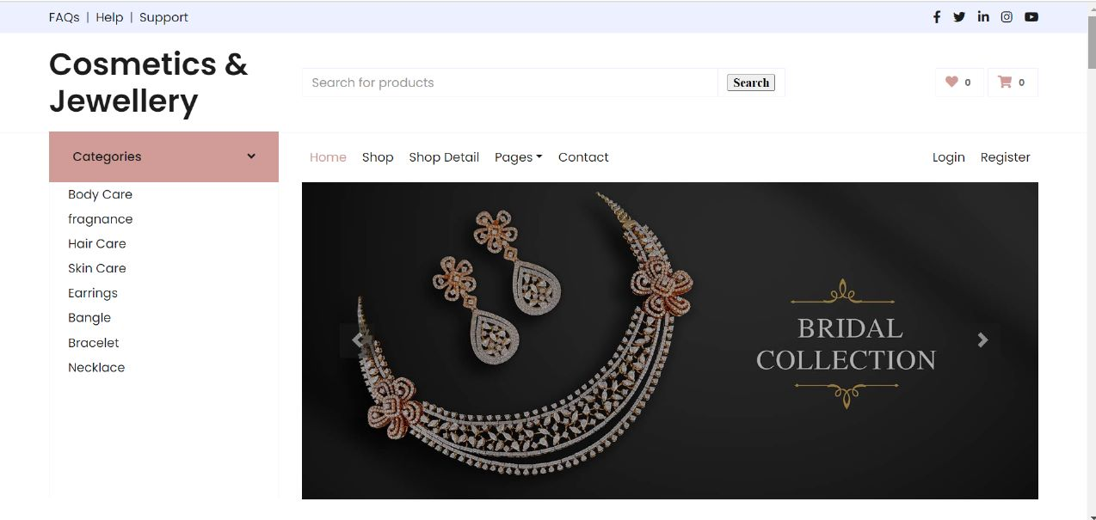

OUR SERVICE

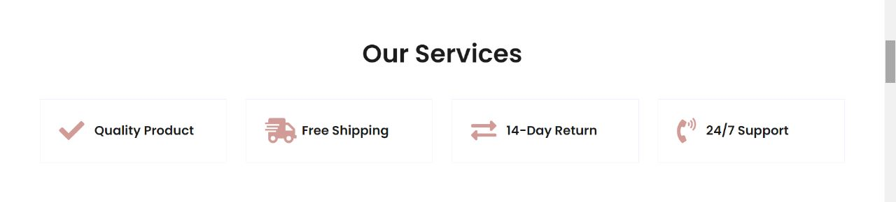

DISCOUNT OFFER



OUR PRODUCTS

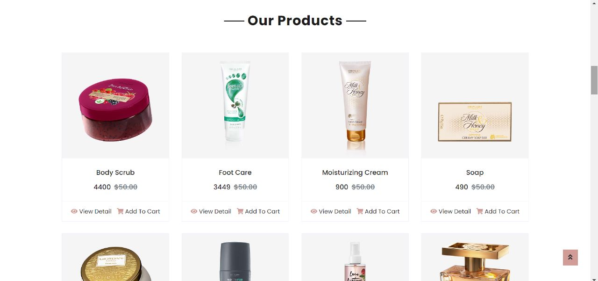

OUR BRANDS



OUR SHOP



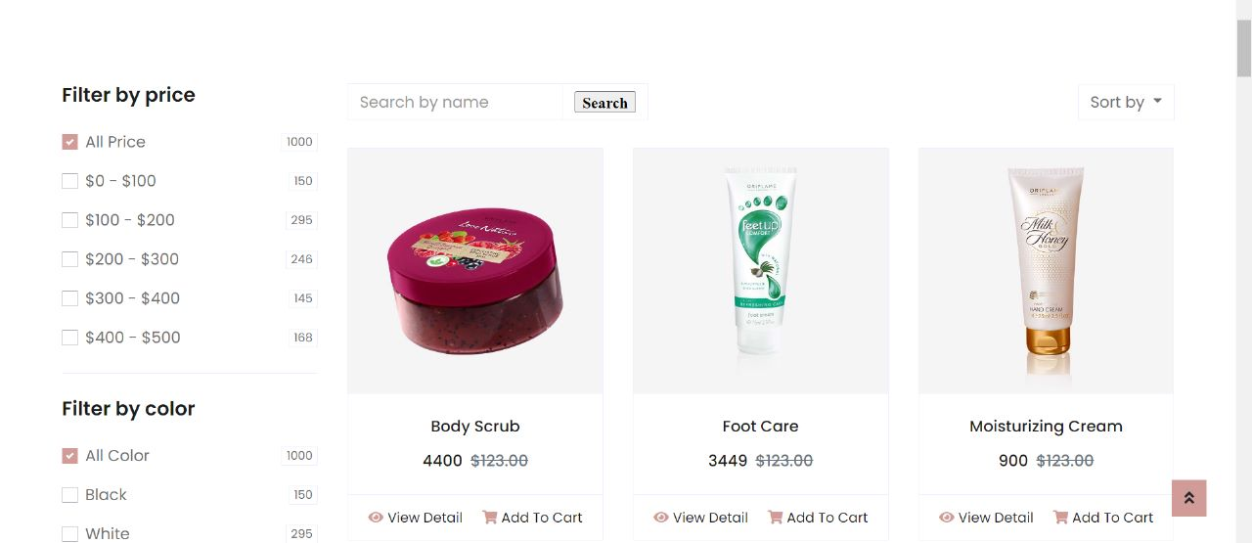

OUR CONTACT



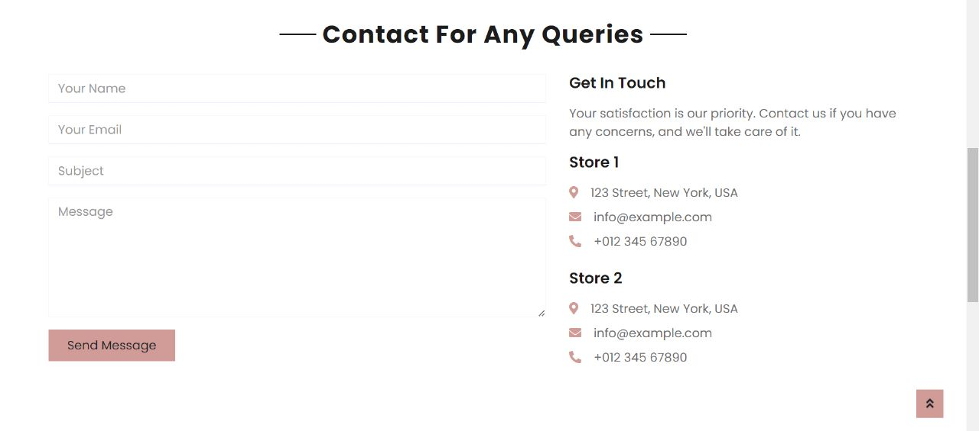

FOOTER

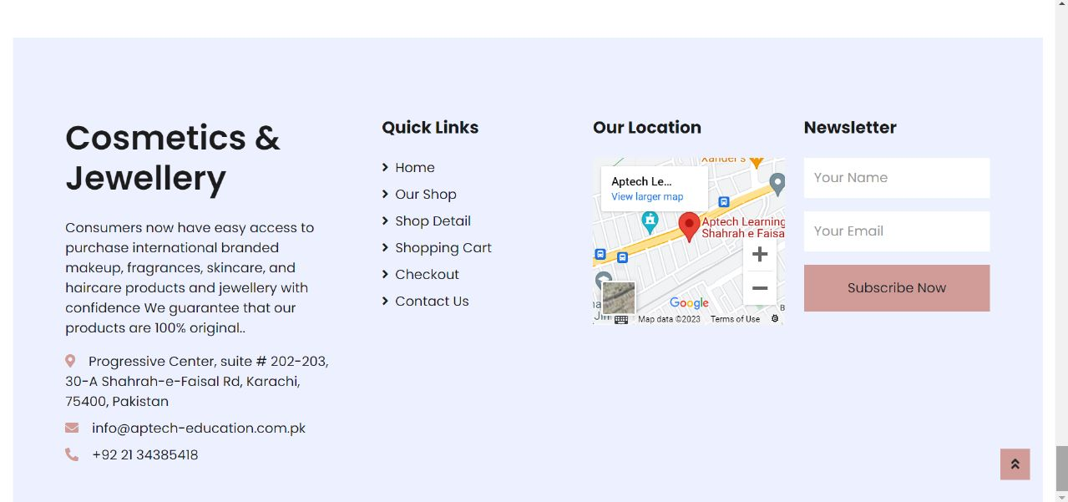

LOGIN FORM

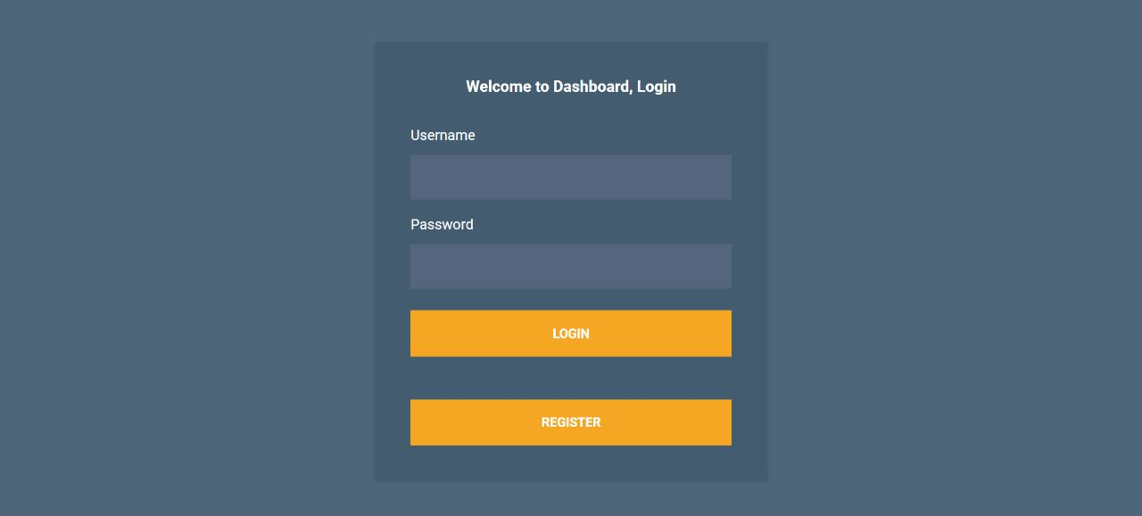

REGISTER FORM

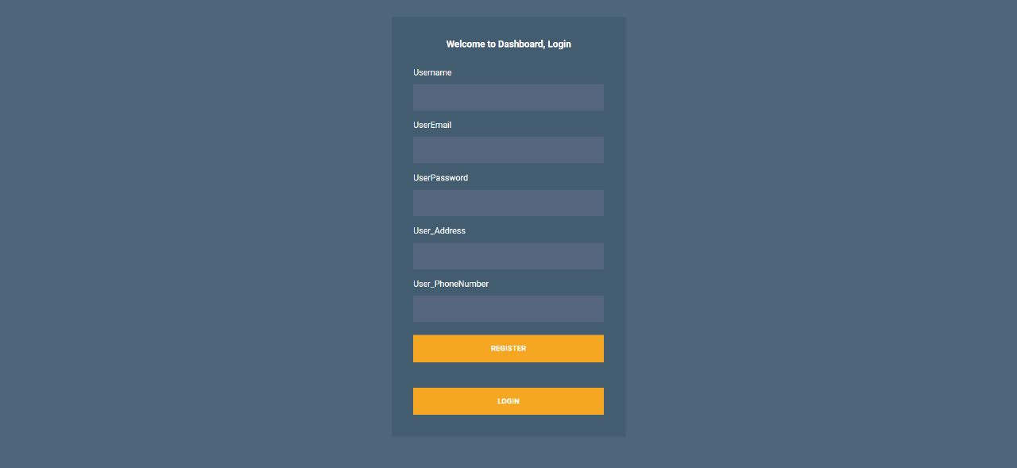

DASHBOARD

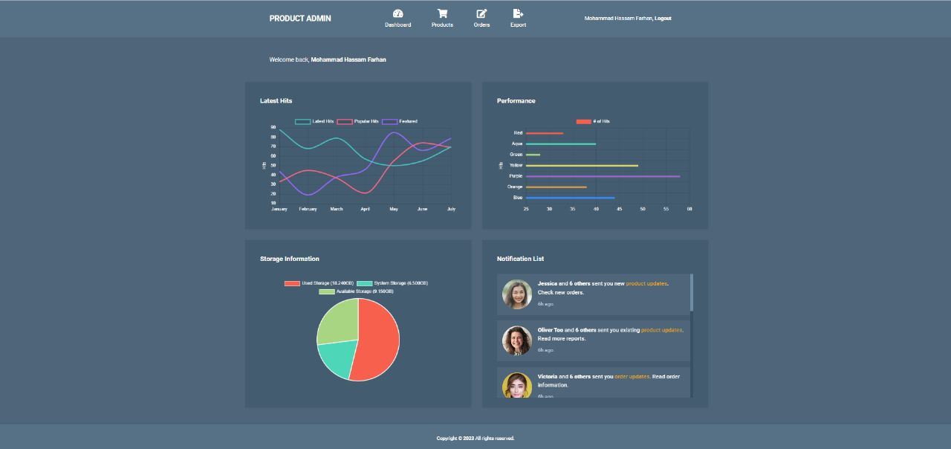

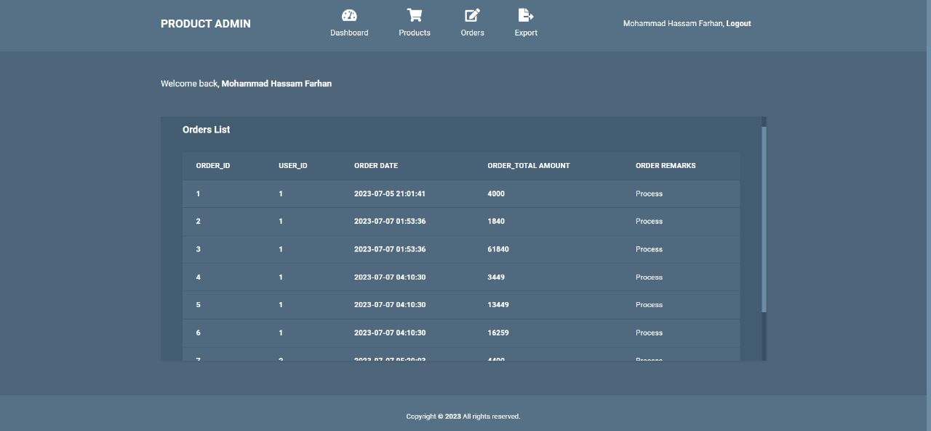

DATABASE

